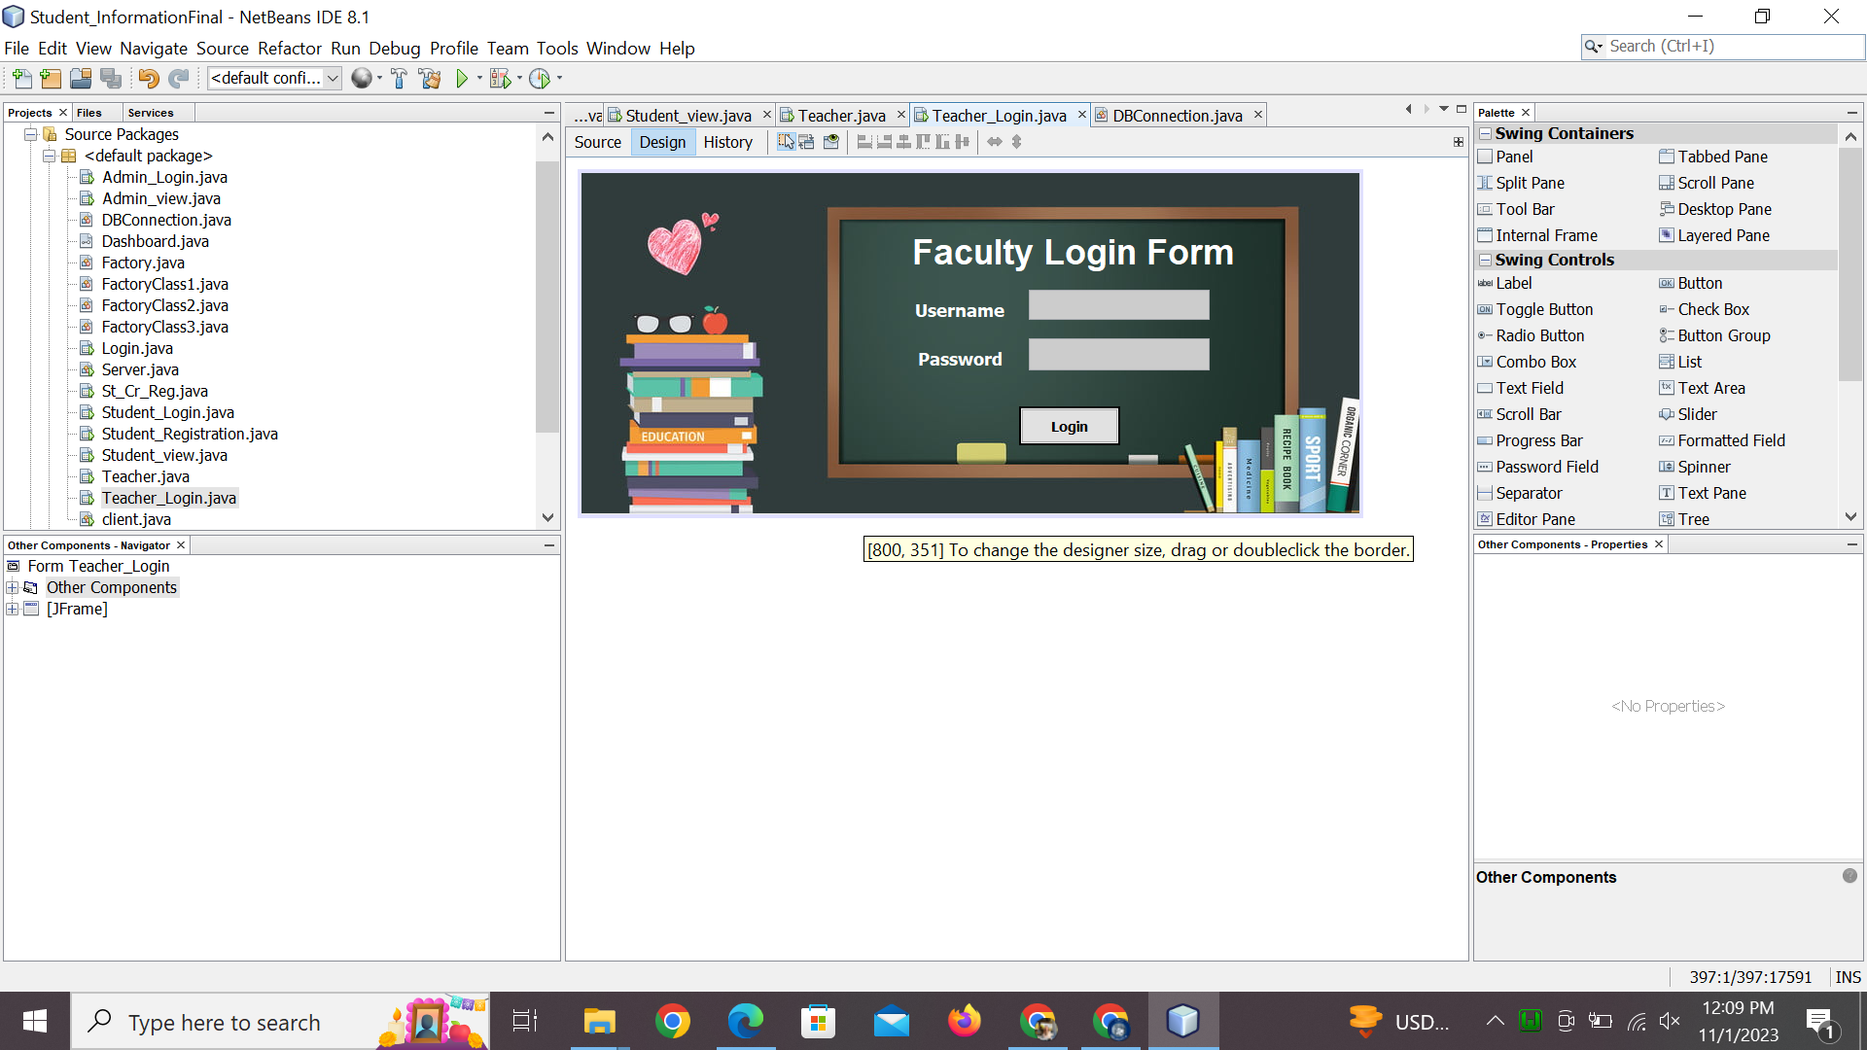

import java.sql.Connection;

import java.sql.Connection;

import java.sql.ResultSet;

import java.sql.Statement;

import javax.swing.JOptionPane;

/*

* To change this license header, choose License Headers in Project Properties.

* To change this template file, choose Tools | Templates

* and open the template in the editor.

*/

/**

*

* @author dell

*/

public class Teacher_Login extends javax.swing.JFrame {

Connection con=DBConnection.getDBConnection();

/**

* Creates new form Teacher_Login

*/

public Teacher_Login() {

initComponents();

}

/**

* This method is called from within the constructor to initialize the form.

* WARNING: Do NOT modify this code. The content of this method is always

* regenerated by the Form Editor.

*/

@SuppressWarnings("unchecked")

// <editor-fold defaultstate="collapsed" desc="Generated Code">

private void initComponents() {

tlogin = new javax.swing.JButton();

tusername = new javax.swing.JTextField();

tpassword = new javax.swing.JTextField();

jLabel1 = new javax.swing.JLabel();

jLabel2 = new javax.swing.JLabel();

jLabel3 = new javax.swing.JLabel();

jLabel4 = new javax.swing.JLabel();

jLabel5 = new javax.swing.JLabel();

setDefaultCloseOperation(javax.swing.WindowConstants.EXIT_ON_CLOSE);

getContentPane().setLayout(new org.netbeans.lib.awtextra.AbsoluteLayout());

tlogin.setFont(new java.awt.Font("Tahoma", 1, 14)); // NOI18N

tlogin.setText("Login");

tlogin.setBorder(javax.swing.BorderFactory.createMatteBorder(2, 2, 2, 2, new java.awt.Color(0, 0, 0)));

tlogin.addActionListener(new java.awt.event.ActionListener() {

public void actionPerformed(java.awt.event.ActionEvent evt) {

tloginActionPerformed(evt);

}

});

getContentPane().add(tlogin, new org.netbeans.lib.awtextra.AbsoluteConstraints(450, 240, 104, 40));

tusername.setBackground(new java.awt.Color(204, 204, 204));

tusername.setCaretColor(new java.awt.Color(255, 255, 255));

tusername.setSelectionColor(new java.awt.Color(0, 0, 0));

tusername.addActionListener(new java.awt.event.ActionListener() {

public void actionPerformed(java.awt.event.ActionEvent evt) {

tusernameActionPerformed(evt);

}

});

getContentPane().add(tusername, new org.netbeans.lib.awtextra.AbsoluteConstraints(460, 120, 186, 31));

tpassword.setBackground(new java.awt.Color(204, 204, 204));

tpassword.setSelectionColor(new java.awt.Color(0, 0, 0));

tpassword.addActionListener(new java.awt.event.ActionListener() {

public void actionPerformed(java.awt.event.ActionEvent evt) {

tpasswordActionPerformed(evt);

}

});

getContentPane().add(tpassword, new org.netbeans.lib.awtextra.AbsoluteConstraints(460, 170, 186, 33));

jLabel1.setFont(new java.awt.Font("Tahoma", 1, 18)); // NOI18N

jLabel1.setForeground(new java.awt.Color(255, 255, 255));

jLabel1.setHorizontalAlignment(javax.swing.SwingConstants.CENTER);

jLabel1.setText("Username");

getContentPane().add(jLabel1, new org.netbeans.lib.awtextra.AbsoluteConstraints(320, 130, 138, -1));

jLabel2.setFont(new java.awt.Font("Tahoma", 1, 18)); // NOI18N

jLabel2.setForeground(new java.awt.Color(255, 255, 255));

jLabel2.setHorizontalAlignment(javax.swing.SwingConstants.CENTER);

jLabel2.setText("Password");

getContentPane().add(jLabel2, new org.netbeans.lib.awtextra.AbsoluteConstraints(320, 180, 138, -1));

jLabel3.setFont(new java.awt.Font("Arial", 1, 36)); // NOI18N

jLabel3.setForeground(new java.awt.Color(255, 255, 255));

jLabel3.setText("Faculty Login Form");

getContentPane().add(jLabel3, new org.netbeans.lib.awtextra.AbsoluteConstraints(340, 60, -1, -1));

jLabel4.setIcon(new javax.swing.ImageIcon("C:\\Users\\USER\\Desktop\\pix\\fax.jpg")); // NOI18N

getContentPane().add(jLabel4, new org.netbeans.lib.awtextra.AbsoluteConstraints(0, 0, 800, 350));

jLabel5.setText("jLabel5");

getContentPane().add(jLabel5, new org.netbeans.lib.awtextra.AbsoluteConstraints(0, 0, 800, 350));

pack();

}// </editor-fold>

private void tloginActionPerformed(java.awt.event.ActionEvent evt) {

// TODO add your handling code here:

login(tusername.getText(),tpassword.getText());

}

public boolean login(String username, String password){

try{

try{

Statement stm=con.createStatement();

String sql="select * from teacher where Tusername='"+username+"' and Tpassword='"+password+"'";

ResultSet rs= stm.executeQuery(sql);

if(rs.next()){

// dispose();

Teacher teacher=new Teacher(username);

teacher.setVisible(true);

dispose();

return true;

}

else{

JOptionPane.showMessageDialog(this,"invalid id or password");

tusername.setText("");

tpassword.setText("");

return false;

}

// con.close();

}

catch(Exception e){

System.out.println(e.getMessage());

return false;

}

}

catch(Exception e){

System.out.println("Exception "+e);

return false;

}

}

private void tusernameActionPerformed(java.awt.event.ActionEvent evt) {

// TODO add your handling code here:

}

private void tpasswordActionPerformed(java.awt.event.ActionEvent evt) {

// TODO add your handling code here:

}

/**

* @param args the command line arguments

*/

public static void main(String args[]) {

/* Set the Nimbus look and feel */

//<editor-fold defaultstate="collapsed" desc=" Look and feel setting code (optional) ">

/* If Nimbus (introduced in Java SE 6) is not available, stay with the default look and feel.

* For details see http://download.oracle.com/javase/tutorial/uiswing/lookandfeel/plaf.html

*/

try {

for (javax.swing.UIManager.LookAndFeelInfo info : javax.swing.UIManager.getInstalledLookAndFeels()) {

if ("Nimbus".equals(info.getName())) {

javax.swing.UIManager.setLookAndFeel(info.getClassName());

break;

}

}

} catch (ClassNotFoundException ex) {

java.util.logging.Logger.getLogger(Teacher_Login.class.getName()).log(java.util.logging.Level.SEVERE, null, ex);

} catch (InstantiationException ex) {

java.util.logging.Logger.getLogger(Teacher_Login.class.getName()).log(java.util.logging.Level.SEVERE, null, ex);

} catch (IllegalAccessException ex) {

java.util.logging.Logger.getLogger(Teacher_Login.class.getName()).log(java.util.logging.Level.SEVERE, null, ex);

} catch (javax.swing.UnsupportedLookAndFeelException ex) {

java.util.logging.Logger.getLogger(Teacher_Login.class.getName()).log(java.util.logging.Level.SEVERE, null, ex);

}

//</editor-fold>

/* Create and display the form */

java.awt.EventQueue.invokeLater(new Runnable() {

public void run() {

new Teacher_Login().setVisible(true);

}

});

}

// Variables declaration - do not modify

private javax.swing.JLabel jLabel1;

private javax.swing.JLabel jLabel2;

private javax.swing.JLabel jLabel3;

private javax.swing.JLabel jLabel4;

private javax.swing.JLabel jLabel5;

private javax.swing.JButton tlogin;

private javax.swing.JTextField tpassword;

private javax.swing.JTextField tusername;

// End of variables declaration

}